#
# 20180830
# Task description: need to create Input gelf udp.
# Results: The Input was created, but it was not used, because was found already previously created working Input and Streams were created too....
#

[root@m1-graylog-lb01 conf.d]# ls -A1 /etc/keepalived/conf.d/*udp* | sort -h | tail
/etc/keepalived/conf.d/udp-12424-input.conf
/etc/keepalived/conf.d/udp-12455-input.conf
/etc/keepalived/conf.d/udp-12456-input.conf
/etc/keepalived/conf.d/udp-12457-input.conf
/etc/keepalived/conf.d/udp-12458-input.conf
/etc/keepalived/conf.d/udp-12459-input.conf
/etc/keepalived/conf.d/udp-12460-input.conf
/etc/keepalived/conf.d/udp-12461-input.conf
/etc/keepalived/conf.d/udp-12462-input.conf
/etc/keepalived/conf.d/udp-8702-input.conf
[root@m1-graylog-lb01 conf.d]# vim -o /etc/keepalived/conf.d/{udp-12462-input,udp-12463-input}.conf
2 files to edit
[root@m1-graylog-lb01 conf.d]#
[root@m1-graylog-lb01 conf.d]#
[root@m1-graylog-lb01 conf.d]# /etc/init.d/keepalived restart
Stopping keepalived: [ OK ]
Starting keepalived: [ OK ]
[root@m1-graylog-lb01 conf.d]# ipvsadm -L -n | grep -e "12463"
UDP 10.216.40.170:12463 rr
-> 10.217.26.7:12463 Masq 1 0 0
-> 10.217.26.8:12463 Masq 1 0 0
[root@m1-graylog-lb01 conf.d]#

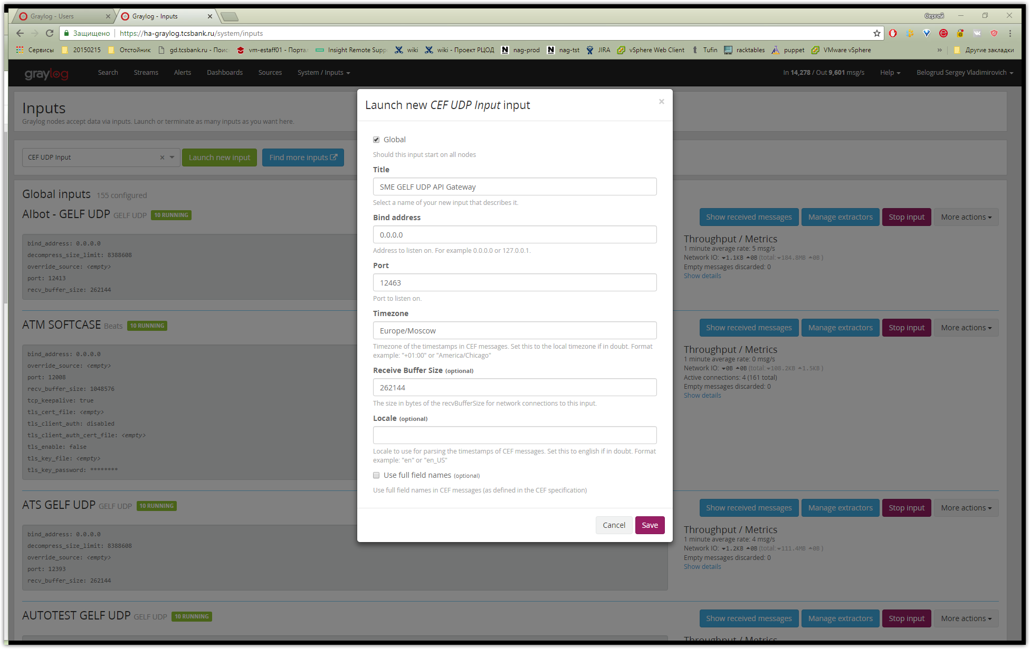

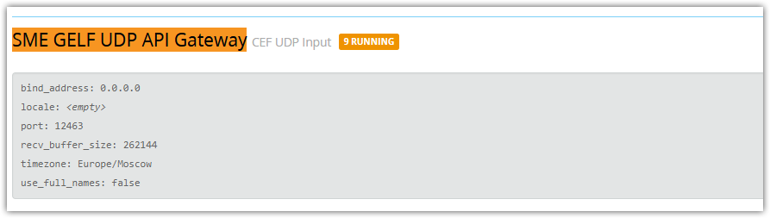

# That’s it…
# Here I’ve stoped.

